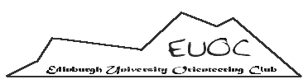

Dear Secretaries,

Auld Reekie Orienteering Society (AROS) is Edinburgh University’s alumni club and we are gradually gaining strength since we were reformed 2 years ago. However due to lack of continuity over many years we no longer have a record of previous EUOC members.

Please would it be possible for you to ask your members to get in touch using the details below if they have been members of EUOC, however briefly, at some point in the past?

As part of the Race the Castles weekends in October 2014 AROS will be holding a celebratory meal for our 50th Anniversary. Therefore we would like to have contacts for as many ex-EUOC members as possible to be able to include them. There will be no requirement to join AROS though the club is available to them if they are not already a member of a closed club.

We look forward to hearing from any previous members.

AROS & EUOC Committees

Contact details:
Jack Baker (EUOC’s current alumni officer)
jackerybakery@gmx.com
Or speak to Lucy Fryer or Ed Nicholas if you see them at an event!

