Improve Your Orienteering With Our Youth Away Days This October
British Orienteering is offering 4 orienteering away days for junior members aged between 12-16 years. This is an exciting opportunity for junior members to attend and experience a day of coaching and take part in adventure activities at various locations across England and Wales in October 2017. Juniors must be able to orienteer at orange level or above.

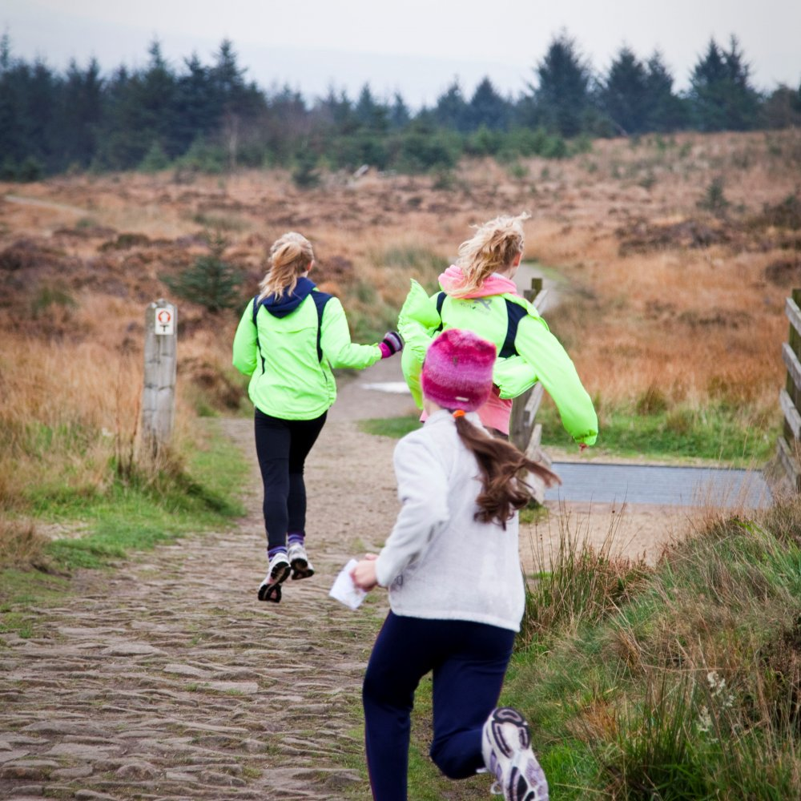

Improve your orienteering with our experienced coaches
Supported by JROS the orienteering will be delivered by experienced British Orienteering licenced coaches. This is an excellent opportunity for young people to be able to develop their orienteering skills with a day of coaching and range of activities. This is a great chance to meet other young people with similar orienteering interests.

Date | Venue | Cost*
Tuesday 17th October | Whitehall Outdoor Centre  Long Hill, Buxton, SK17 6SX | £20
Tuesday 24th October | Sayers Croft Field Centre,  Cranleigh Rd, Ewhurst, Cranleigh, GU6 7SS | £20
Thursday 26th October | Whitehall Outdoor Centre  Long Hill, Buxton, SK17 6SX | £20
Friday 27th October | Kingswood Colomendy  Loggerheads Rd, Cilcain, Mold, CH7 5LB | £20

*Subsidised by Sport England

Places are limited and we encourage you to
book early to avoid disappointment.
Food will be provided.

Have fun with other young orienteers

For further information and to make a booking contact Tim Herod on 07891 091476 or therod@britishorienteering.org.uk

Itinerary for the Youth Away Days
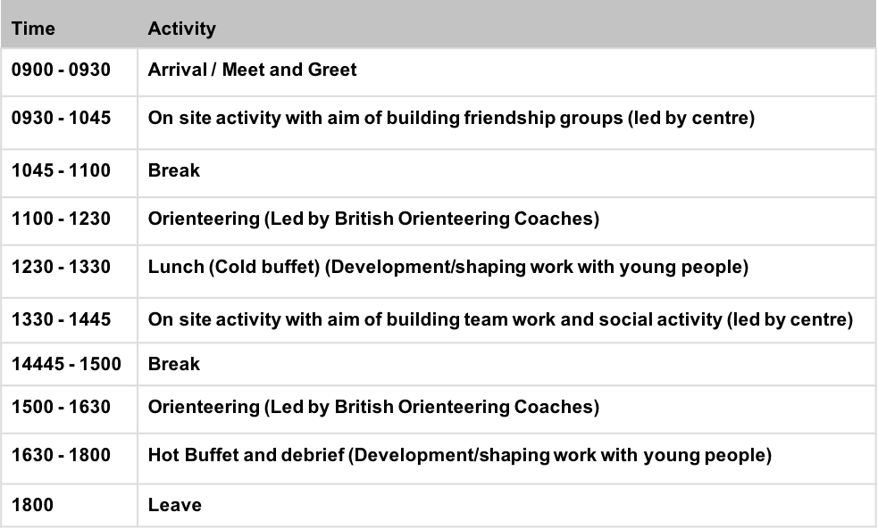
Programme subject to change

Parents Information

Great your daughter or son wants to come to one of the activity days.

We look forward to spending the day with them

Please ensure that you have signed the registration consent letter.

Include membership number and category of each child registering.

Please complete any dietary information.

Please ensure that your child has any medication they need with them.

Please complete any medical conditions that we may need to know about.

Sign photographic permission for child for British Orienteering to promote young people sessions in the future.

Please make sure that your child has a spare set of kit for bad weather conditions.

See if any other people from your club/area are going to a session and share transport.

Make the most of the day, visit local attractions or go and explore a local Permanent Orienteering Course nearby. The 3 venues have numerous local walks and activities close by.

Your children will be taking part in orienteering and adventure activities which will be coached and led by fully qualified staff.

Food and drink is provided but they can bring other snacks and drinks if required.

