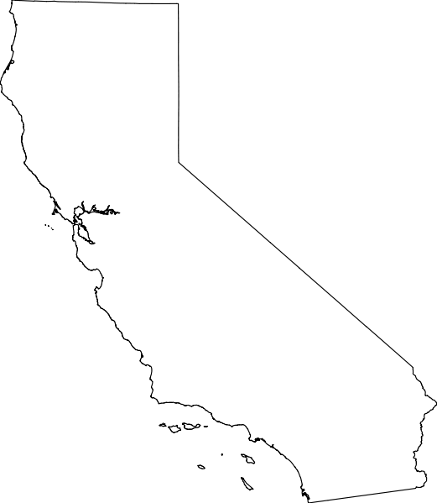
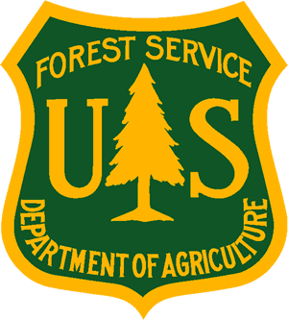
OUTREACH NOTICE
FOREST SERVICE
Pacific Southwest Region – Region 5

GS-0401-11/12 Natural Resources Specialist
(Program Specialist for Invasive Plants/Pesticide Use Programs)
Remote in California as negotiated.
REPLY BY: 05/31, 2024

The USDA Forest Service Region 5 (Pacific Southwest Region), State and Private Forestry is looking to fill a permanent position for a Natural Resources Specialist, GS-0401-11/12. The Duty Station will be “remote: within 50 miles of a Forest Service office in Northern California”.

Responses to this outreach notice will be used to determine how the permanent vacancy announcement will be advertised, such as grade levels, and whether the announcement will be open to non-federal applicants.

Interested applicants should submit a completed outreach response form (see form below). Please submit forms to Stacey Clark at stacey.clark@usda.gov. Responses due May 31, 2024.

Duties: This specialist implements program provisions authorized under the Cooperative Forestry Assistance Act associated with providing forest landowner assistance for invasive plant management in forestlands of California, as well as providing support for National Forest System Lands in invasive plant management and pesticide use. The program specialist is responsible for providing technical guidance and leadership and assisting with the planning, implementation, and coordination of regional forestry assistance programs with state forestry agencies and other partners.

Provides technical assistance, in cooperation with partners, to enhance technical skills. Assists with grants, policies, and training that includes other Forest Service staffs, other Federal agencies, State, and local officials, Tribes, and non-governmental organizations.

Provides project management support and coordination. Identifies enhancements to improve program area and works with partners to develop strong and competitive projects.

Responds to requests for information on assigned program. Assists in maintaining awareness of program area with respect to achieving the Forest Service mission. Provides information on the value and benefit of assigned program and evaluates the implications on various public policy/proposals as related to the program. Participates in and as needed coordinates with state, regional and national reviews.

Develops and administers multiple program grants and cooperative agreements with state and private entities consistent with OMB and agency regulations and policies. Develops program and funding advice and direction. Oversees/administers all stages of the award process from pre-award terms and negotiation, to post award administration and close out. Conducts periodic compliance monitoring which may include technical on-site monitoring of grantee performance to assess progress towards award objectives including technical and financial obligations. Reviews and approves payment requests.
Performs other duties as assigned.
Duty Location: This position is allowed to be remote within 50 miles of a Forest Service Office in Northern California with location negotiable.
Area Description: The Pacific Southwest Region, Region 5 (R5) of the USDA Forest Service encompasses California, Hawai'i and the U.S.-affiliated Pacific Islands (USAPI). Information about the R5, Pacific Southwest Region can be found at http://www.fs.usda.gov/r5/. California has

Contact: For questions or more information about this position, please contact Stacey Clark at stacey.clark@usda.gov

OUTREACH REPLY FORM
Please respond by ?, 2024

Pacific Southwest Region
Natural Resource Specialist – Invasive Plants Program/Pesticide Use Program
GS-0401-11/12

Please return this form and a copy of your resumé to:

Stacey Clark, Invasive Plants Program Manager & Pesticide Use Coordinator, State & Private Forestry, Pacific Southwest Region at stacey.clark@usda.gov

Name: _______________________________________________________________________

E-Mail Address: _______________________________________________________________

Mailing Address: ______________________________________________________________

Phone Number: _______________________________________________________________

Agency Employed With: ______ USFS _____ BLM ______ OTHER: ________________

Type of Appointment: ______ PERMANENT _____ TEMPORARY _____ TERM
______ VRA _____ PWD _____ OTHER

Current Region/Forest/District: __________________________________________________

Current Service and Grade, if applicable: __________________________________________

Current Position Title: _________________________________________________________

Where did you hear about this vacancy/outreach? _____________________________

If not a current permanent (Career or Career Conditional) employee, are you eligible to be hired under any of the following special authorities?

____ Person with Disabilities
____ Disabled Veteran with 30% Compensable Disability
____ Veterans Employment Opportunities Act of 1998
____ Former Peace Corps Volunteer
____ Veterans Recruitment Act
____ Pathways Students and Recent Graduates
____ Other: ___________________________

SUBMISSION OF THIS FORM IS VOLUNTARY—THANK YOU FOR YOUR INTEREST!

The U.S. Department of Agriculture (USDA) prohibits discrimination in all its programs and activities on the basis of race, color, national origin, age, disability, and where applicable, sex, marital status, familial status, parental status, religion, sexual orientation, genetic information, political beliefs, reprisal, or because all or part of an individual’s income is derived from any public assistance program. (Not all prohibited bases apply to all programs.) Persons with disabilities who require alternative means for communication of program information (Braille, large print, audiotape, etc.) should contact USDA’s TARGET Center at (202) 720-2600 (voice and TDD). To file a complaint of discrimination, write USDA, Director, Office of Civil Rights, 1400 Independence Avenue, S.W., Washington, D.C. 20250-9410, or call (800) 795-3272 (voice) or (202) 720-6382 (TDD).

