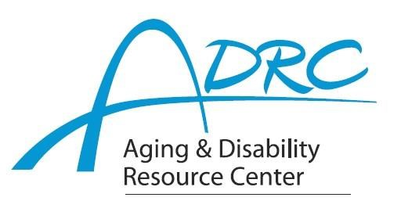

Of Rock County

**1717 Center Avenue, Janesville**

**October 2, 2024**

**FOR IMMEDIATE RELEASE**

Contact: Karen Tennyson, Dementia Care Specialist, ADRC of Rock County

608.741.3615 or karen.tennyson@co.rock.wi.us

**You are cordially invited to**

**A Day at the Club – A Caregivers Retreat**

**Please Join Us for this Complimentary Event to Honor Family Caregivers**

**on Wednesday, November 6th from 9am-4pm**

**The ADRCs of Jefferson, Rock & Dane Counties are pleased to host**

**A day of pampering and information for family caregivers**

On Wednesday, November 6, 2024 The Aging & Disability Resource Centers of Jefferson, Rock & Dane Counties will host a day to honor family caregivers at The Fort Atkinson Club – 211 S. Water Street E, Fort Atkinson, WI.

The day starts with a variety of spa and relaxation services sponsored in part by Tomorrow’s Hope and facilitated by students from Madison College. The Intergenerational Technology program from UWW will also host appointments to assist with technology questions. Lunch by Bon Ton Bakery catering is included and will be followed by an afternoon of informative conversation about a variety of topics related to caring for an adult with chronic illness including safety, security, technology, research and perspectives from a family caregiver and person with a dementia diagnosis.

Full and half day sessions are available to meet scheduling needs. Respite care for your family member facilitated by BrightStar, Home Instead, students of Madison College and Memories in the Making is available based on need and with a prior registration for services. This is a complimentary event. **Preregistration is required. Please contact Karen Tennyson at 608/741-3615 for more information and to complete a registration.**

For more information on the dementia care specialist program and services available, please contact your local Aging & Disability Resource Center.

####