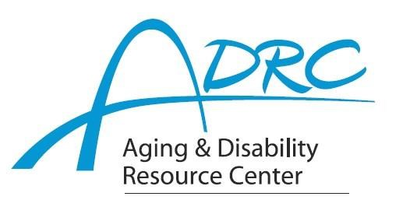



# FOR IMMEDIATE RELEASE

August 6, 2024

Contact: Karen Tennyson, Dementia Care Specialist, ADRC of Rock County

608.741.3615 or karen.tennyson@co.rock.wi.us

**The Time is Now to Register for**

**Powerful Tools for Caregivers**

**Education Series**

**Offered by Rock, La Crosse & Eau Claire Counties**

**Feeling Stretched as a Caregiver?**

The Aging and Disability Resource Centers of Rock, La Crosse and Eau Claire Counties are pleased to offer *Powerful Tools for Caregivers*, an educational series designed to provide family caregivers of someone with dementia the tools needed to take care of themselves beginning Wednesdays from September 18 through October 23, 2024, from 6-7:30pm. This series will be offered virtually.

Held over 6 weeks, The *Powerful Tools for Caregivers* program helps family caregivers reduce stress, improve self-confidence, improve communication, balance their lives, increase their ability to make tough decisions and locate helpful resources. Interactive lessons, discussions and brainstorming help caregivers to choose tools and put them into action.

**Registration is required. Class space is limited.** For more information or to register, in Rock County contact Karen Tennyson at 608-741-3615 or [karen.tennyson@co.rock.wi.us](mailto:karen.tennyson@co.rock.wi.us).