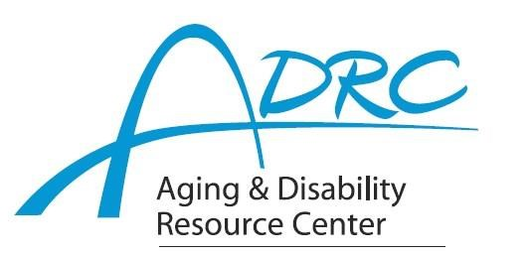

Of Rock County

**1717 Center Avenue, Janesville**

April 15, 2024

**FOR IMMEDIATE RELEASE**

Contact: Karen Tennyson, Dementia Care Specialist, ADRC of Rock County

608/741-3615 or karen.tennyson@co.rock.wi.us

**RESERVE NOW – SPACE IS LIMITED TO 100**

**State of the State of Dementia in Wisconsin**

**June 5, 2024 - 9am-3:30pm - University of Whitewater Community Engagement Center**

A conference for all professionals in aging and healthcare, the day’s expert speakers will provide valuable insight and information regarding the 2024-2028 Wisconsin State Dementia Plan. Conference speakers and presentations include:

“2024-2028 State Dementia Plan Overview”

Carrie Molke, director Bureau of Aging & Disability Resources, Department of Health Services

Bryce Dorff, research analyst, Department of Health Services

“Adult Protective Services, Dementia & Crisis”

Laurie Kohler, APS coordinator, Department of Health Services

chaired crisis response workgroup for the 2024-2028 plan

“Dementia, Stabilization, In-Patient Psychiatric Units & the Law”

Jake Dunn, MSW, LCSW, Stoughton Hospital – geriatric psychiatry

“Family Caregiver Concerns and Community Education”

Bonnie Nuttkinson, MS, research program coordinator dementia care & caregiver research

Wisconsin Alzheimer’s Disease Research Center

Karen Tennyson, MSW, LCSW, CDP, dementia care specialist, ADRC of Rock County

Conference fee is $25 & includes all-day conference, 4 CEUs sponsored by UW-Whitewater and lunch.

**Registration is required.** For registration information, please contact Karen Tennyson, dementia care specialist, Rock County 608/741-3615 or [karen.tennyson@co.rock.wi.us](mailto:karen.tennyson@co.rock.wi.us).

####