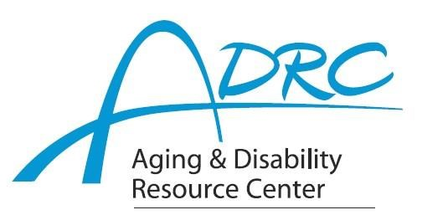

Of Rock County

**1717 Center Avenue, Janesville**

March 4, 2024

**FOR IMMEDIATE RELEASE**

Contact: Karen Tennyson, Dementia Care Specialist, ADRC of Rock County

608/741-3615 or karen.tennyson@co.rock.wi.us

**Conference for Professionals in Aging & Dementia**

**State of the State of Dementia in Wisconsin**

**June 5, 2024 - 9am-3:30pm - University of Whitewater Campus Area**

This is a conference for professional caregivers including social workers, nurses, case managers, long-term care managers and other professionals that work with older adults and those with a dementia diagnosis. The day’s expert speakers will provide valuable insight and information regarding the 2024-2028 Dementia State Plan. Conference speakers and presentations include:

“2024-2028 State Dementia Plan overview”

Department of Health Services

“Adult Protective Services, Dementia & Crisis”

Laurie Kohler, APS coordinator, Department of Health Services

Chaired crisis response workgroup for the 2024-2028 plan

“Dementia, Stabilization, In-Patient Psychiatric Units & the Law”

Jake Dunn, MSW, LCSW, Stoughton Hospital – geriatric psychiatry

“Family Caregiver Concerns and Community Education”

Bonnie Nuttkinson, MS, Research Program Coordinator Dementia Care & Caregiver Research

Wisconsin Alzheimer’s Disease Research Center

Karen Tennyson, MSW, LCSW, CDP, Dementia Care Specialist, ADRC of Rock County

Conference fee is $25 & includes all-day conference, CEUs sponsored by UW-Whitewater and lunch.

**Registration is required.** For registration information, please contact Karen Tennyson, dementia care specialist, Rock County 608/741-3615 or [karen.tennyson@co.rock.wi.us](mailto:karen.tennyson@co.rock.wi.us).

####