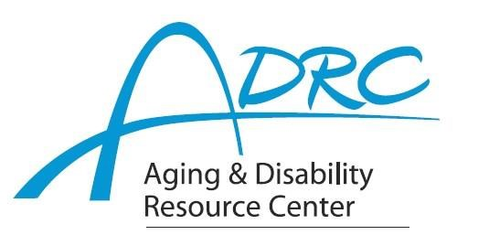

Of Rock County

**1717 Center Avenue, Janesville**

January 16, 2024

**FOR IMMEDIATE RELEASE**

Contact: Karen Tennyson, Dementia Care Specialist, ADRC of Rock County

608.741.3615 or karen.tennyson@co.rock.wi.us

**A few spots still available**

**Virtual Caregiver Class**

**Stress-Busting Program for Family Caregivers of People with Dementia**

**Thursday evenings February 15 – April 11, 2024 6-8pm**

**Registration is required by February 8th.**

The Aging & Disability Resource Centers of Rock and Marquette Counties are offering the 9-week Stress-Busting for Family Caregivers of People with Dementia virtual class as developed at the University of Texas Health Science Center by Sharon Lewis and the WellMed Charitable Foundation beginning Thursday February 15 from 6-8pm.

**Who is SBP for?** Anyone caring for someone with a form of dementia will benefit from the program. **What is SBP?** The Stress-Busting Program for Family Caregivers of People with Dementia is a proven curriculum developed by Sharon L. Lewis, RN, PhD, FAAN in conjunction with the University of Texas Health Science Center and the WellMed Charitable Foundation which teaches stress management, relaxation tools, coping strategies and problem-solving skills with a support group component. Participates view the program as a source of strength and support for their caregiving role.

“Caregivers of someone with dementia experience high levels of stress, anxiety and depression. Dealing with those issues in a healthy way is vital to a caregiver’s well-being. Consequently, to care for the person with dementia, the caregiver must first learn how to care for themselves.”, said Karen Tennyson dementia care specialist at the Aging and Disability Resource Center of Rock County.

Reserve your spot today for the Stress-Busting Program for Family Caregivers of People with Dementia by contacting Karen Tennyson at 608-741-3615 or [karen.tennyson@co.rock.wi.us](mailto:karen.tennyson@co.rock.wi.us).

####