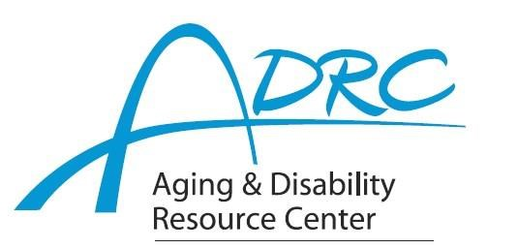

Of Dane and Rock Counties

December 20, 2023

**FOR IMMEDIATE RELEASE DEMENTIA PROGRAM**

**Contact:** Karen Tennyson, Dementia Care Specialist, ADRC of Rock County

608-741-3615 or [karen.tennyson@co.rock.wi.us](mailto:karen.tennyson@co.rock.wi.us)

Ellen Taylor or Kayla Olson, Dementia Care Specialists, ADRC of Dane County

[danedcs@countyofdane.com](mailto:danedcs@countyofdane.com)

**How are you handling the holidays?**

**Caregiver GPS**

**Learn how to navigate the journey of family caregiving**

We invite you to join the Aging and Disability Resource Centers of Rock and Dane Counties for a year-long, virtual, family caregiver education series. Webinars will be offered the 3rd Thursday of each month from Noon-1pm beginning January 18, 2024. There is no cost to join. Registration is required to obtain the link. Join when you can for topics that interest you.

Family caregivers will learn from experts about topics including: dementia information; communication skills for dementia caregivers; legal, financial and crisis planning; home safety; assistive devices; having difficult conversations; resource connections; travel planning as a caregiver and enjoying your holidays. Each session will allow for question-and-answer time.

For a schedule of topics, more information or to register for the link, please contact

Rock County Dementia Care Specialist, Karen Tennyson at 608/741-3615 or [karen.tennyson@co.rock.wi.us](mailto:karen.tennyson@co.rock.wi.us)

Dane County Dementia Care Specialists, Ellen Taylor and Kayla Olson at [danedcs@countyofdane.com](mailto:danedcs@countyofdane.com)

####