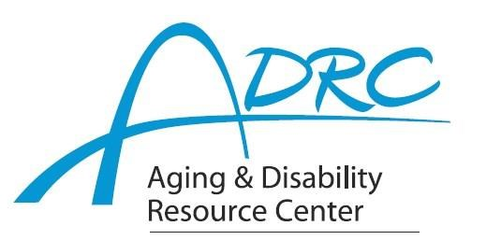



# FOR IMMEDIATE RELEASE

August 2, 2023

Contact: Karen Tennyson, Dementia Care Specialist, ADRC of Rock County

608.741.3615 or karen.tennyson@co.rock.wi.us

**Limited Spots Available**

**Powerful Tools for Caregivers**

**Education Series**

**Offered by Rock & Jefferson Counties**

**Feeling Stretched as a Caregiver?**

The Aging and Disability Resource Centers of Rock and Jefferson Counties are pleased to offer *Powerful Tools for Caregivers*, an educational series designed to provide family caregivers of someone with dementia the tools needed to take care of themselves. The class will run for 6 weeks beginning on Thursday September 21, 2023 from 5:30-7pm. This series will be offered virtually.

The *Powerful Tools for Caregivers* program helps family caregivers reduce stress, improve self-confidence, improve communication, balance their lives, increase their ability to make tough decisions and locate helpful resources. Interactive lessons, discussions and brainstorming help caregivers to choose tools and put them into action.

**Registration is required. Class space is limited.** For more information or to register, contact

Tonya Runyard at the ADRC of Jefferson county 920/675-4035 or [tonyar@jeffersoncountywi.gov](mailto:tonyar@jeffersoncountywi.gov) or

Karen Tennyson at 608-741-3615 or [karen.tennyson@co.rock.wi.us](mailto:karen.tennyson@co.rock.wi.us).