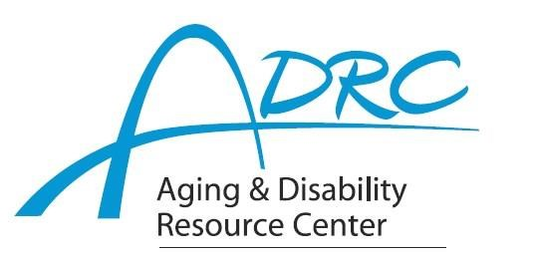

Of Rock County

**1717 Center Avenue, Janesville**

**May 1, 2023**

**FOR IMMEDIATE RELEASE**

Contact: Karen Tennyson, Dementia Care Specialist, ADRC of Rock County

608/741-3615 or karen.tennyson@co.rock.wi.us

**Dementia And…A Professional Caregiver Conference**

**Tuesday June 6, 2023**

**At**

**The Dr. Daniel Hale Williams Resource Center, Janesville**

**Reserve Your Spot Today**

Dementia And is a conference for professional caregivers including social workers, nurses, first responders, law enforcement and other professionals that work with older adults and those with a dementia diagnosis. The day’s slate of expert speakers will build on foundations of dementia, diagnostic evaluation, dementia-related behavioral symptoms and intervention approaches to provide a board base of knowledge correlating research, experience and innovation.

Conference speakers and presentations include:

Dementia And…Highlights and Diagnostic Evaluation

Dr. Georgine Dudzek, Psy. D – Synapse Solutions, Janesville

Dementia And…Behavioral Expressions: Misconceptions & Misunderstandings

Dr. Tracy Schroepfer, PhD, MSW, MA – UW-Madison Sandra Rosenbaum School of Social Work

Dementia And…Interventions for Behavioral Expressions

Bonnie Nuttkinson, MS – Wisconsin Alzheimer’s Disease Research Center

Dementia And…Compassion Fatigue and Self-Care

DeAnna Brown, CSW – Mercyhealth

Family Caregiver panel discussion

Two CEs and two educational contact hours are available. Lunch, break and conference workbook will be included. Conference fee is $25.

**Pre-registration is required.** To make reservations please contact Karen Tennyson, dementia care specialist of Rock County at (608) 741-3615.