**The Aging and Disability Resource Centers of**

**Rock and Jefferson Counties are offering a virtual**



**Powerful Tools for Caregivers** classes help caregivers take better care of themselves while caring for someone with dementia. Whether you provide care for a spouse, partner, parent or friend; at home or in a care facility, whether down the block or miles away, yours is an important role. This course is for family caregivers like you!

This virtual six-week class series beginning **Thursday, May 4, 2023** gives you the confidence and support to better care for your loved one – and yourself. The class will be held from **2-3:30pm through June 8, 2023**. **Registration is required.**

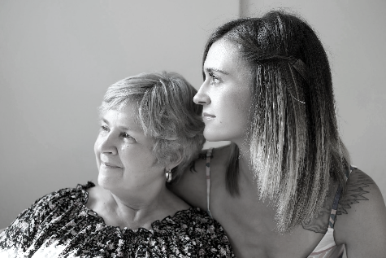***The classes give caregivers tools to help:***

* Reduce stress
* Improve self-confidence
* Manage time, set goals, and solve problems
* Better communicate your feelings
* Make tough decisions
* Locate helpful resources

Caregivers receive *The Caregiver Helpbook,* which follows the curriculum and provides additional tools to address specific caregiver issues.

**For more information or to register, please contact Tonya Runyard, Jefferson County ADRC 920/675-4035 or Karen Tennyson, Rock County ADRC 608/741-3615.**

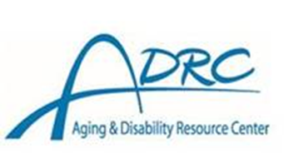  

*Powerful Tools for Caregivers* is owned and managed by Iowa State University of Science and Technology.