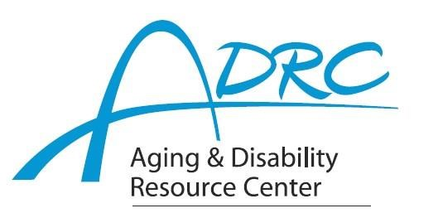

Of Rock County

**1717 Center Avenue, Janesville**

**March 28, 2023**

**FOR IMMEDIATE RELEASE**

Contact: Karen Tennyson, Dementia Care Specialist, ADRC of Rock County

608.741.3615 or karen.tennyson@co.rock.wi.us

**SAVE THE DATE**

**Tuesday, June 6th**

**For**

**Dementia And…**

**A Professional Caregiver Conference**

The Aging & Disability Resource Center of Rock County is pleased to present Dementia And…A Professional Caregiver Conference on Tuesday, June 6th at the Dr. Daniel Hale Williams Resource Center in Janesville from 10am – 5pm. This in-person event will provide dynamic speakers on a variety of topics that directly affect those providing professional care for people living with dementia and their care partners. Our keynote speaker is Dr. Tracy Schroepfer professor at the University of Wisconsin-Madison Sandra Rosenbaum School of Social Work presenting Dementia And…Behavioral Expressions: Misconceptions and Misunderstandings.

**Who is this conference for?** This conference is for all those who provide professional, paid care and services to people living with dementia and their care partners such as social workers, nurses, physicians, first responders, long-term care staff and administrators, hospice providers, case managers, ancillary therapy providers, hospital staff, in-home care providers and aging agency staff.

More information will follow but please feel free to contact Karen Tennyson at 608/741-3615 or [Karen.tennyson@co.rock.wi.us](mailto:Karen.tennyson@co.rock.wi.us) with any questions.