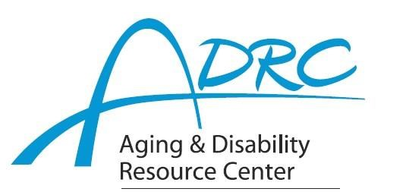

Of Rock County

**1717 Center Avenue, Janesville**

**March 1, 2023**

**FOR IMMEDIATE RELEASE**

Contact: Karen Tennyson, Dementia Care Specialist, ADRC of Rock County

608/741-3615 or karen.tennyson@co.rock.wi.us

**Healthy Living with Mild Cognitive Impairment (MCI) Education Series**

In partnership with the Wisconsin Alzheimer’s Disease Research Center and the Alzheimer’s Association, the ADRC of Rock County, is pleased to be one of three in-person satellite locations for the state to present the Healthy Living with Mild Cognitive Impairment Education Series throughout 2023. The four programs being offered provide guidance and science-backed strategies for those living and coping with a diagnosis of MCI and their care partners.

Join Nathaniel Chin, MD and Bonnie Nuttkinson, MS from the Wisconsin Alzheimer’s Disease Research Center along with Jennifer McAlister, BA from the Alzheimer’s Association Wisconsin Chapter and expert guest speakers to learn more about MCI and how to prepare for and cope with the diagnosis.

Please attend one or all of the series’ sessions. The ADRC of Rock County will be hosting an in-person viewing option for the series at their office location 1717 Center Avenue, Janesville on the following dates from 9:15am – 1pm:

**Friday March 24th – Brain Boosters: Strategies to Strengthen Your Mind; Kimberly Mueller, PhD**

**Friday June 9th – Food Matters: The Gut-Brain Connection; Barbara Bendlin, PhD**

**Friday Sept. 8th – Manage Stress & Improve Coping Skills for a Healthier Mind; Megan Zuelsdorff, PhD**

**Friday Dec. 8th – Personalize Exercise to Boost Brain Health & Memory; Michelle Braun, PhD**

A light lunch will be served. An open discussion about the session will follow the viewing. This is a free educational opportunity. **Reservations are required.** To make reservations please contact Karen Tennyson, dementia care specialist of Rock County at (608) 741-3615.

####