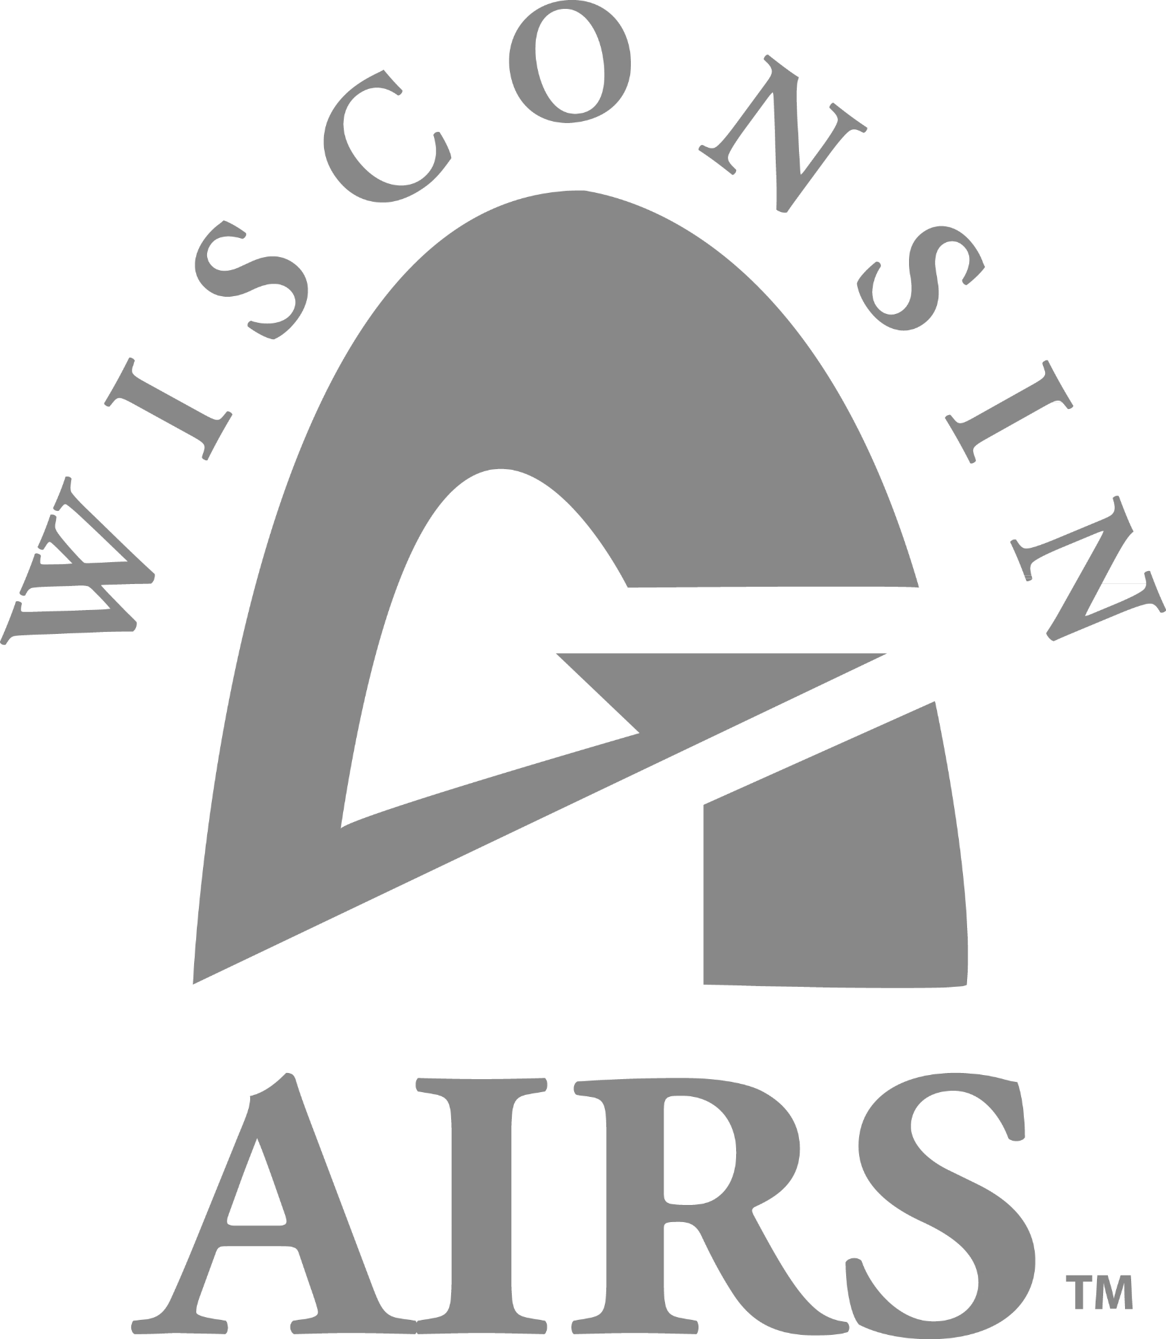

**November 11th & 12th, 2021**

**Virtual Conference**

**41st Annual WisconsinAIRS**

**Conference**

[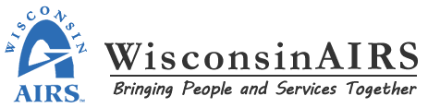](https://wisconsinairs.com/)**41st Annual WisconsinAIRS Conference**

**November 11th – 12th 2021**

**Conference Objectives**

1. To provide opportunities for knowledge enhancement and skill development for professionals in the field of information and referral/assistance.
2. Promote excellence and professionalism in the fields of I&R and I&A.
3. Provide a vehicle for training, peer support and communication.
4. To convey the mission, purpose about WisconsinAIRS.
5. To offer opportunities for professionals in the field of information and referral/assistance to learn from each other and their experiences and background.

**Intended Participants**

* 2-1-1 Centers
* Aging & Disability Resource Centers
* Alzheimer’s Agencies
* Area Agencies on Aging
* Brain Trauma Associations/Agencies
* Cancer Associations/Agencies
* Child Care Resource & Referral Agencies
* County/Tribal Aging Departments
* Crisis Centers
* Family Resource Centers
* Hospital Sponsored Information & Referral Programs
* Independent Information & Referral

Agencies and Programs

* Independent Living Centers (ILC)
* Mental Health Resource Centers
* Parkinson’s Agencies
* Public Libraries
* Student Interns
* United Ways

|  |  |
| --- | --- |
| **Table of Contents** | |
| **3** | Conference Agenda |
| **4-5** | Group Training |
| **6** | Ethics & Boundaries and Join Our Board |
| **7** | General Conference Registration & Fees |
| **8** | WisconsinAIRS Information |
| **9** | Alliance of Information & Referral Systems Information |

[](https://wisconsinairs.com/)

**41st Annual WisconsinAIRS Conference**

**November 11th & 12th, 2021**

CONFERENCE AGENDA

|  |  |  |
| --- | --- | --- |
| **THURSDAY, November 11th, 2021** | |  |
| **8:15a – 8:45a** | WisconsinAIRS Annual Board Meeting |  |
| **8:55a – 9:55a** | AIRS Benefits Explained |  |
| **9:55a – 10:05a** | **Break** |  |
| **10:05a** – **12:05p** | Laying the Foundation: Privilege, Implicit Bias, and Systemic Oppression |  |
| **12:05p – 12:45p** | Lunch |  |
| **12:45p – 2:45p** | ACE’s, Collective Trauma and the Path to Healing |  |
| **2:45p – 3:00p** | **Break** |  |
| **3:00p – 4:00p** | Healing Ourselves with Self-Care |  |
| **FRIDAY, November 12th, 2021** | |  |
| **8:30a – 10:30a** | Ethics & Boundaries: Risk, Vulnerability, and Resilience in Practice |  |
| **10:30a – 10:45a** | **Break** |  |
| **10:45a – 12:30p** | Ethics & Boundaries: Risk, Vulnerability, and Resilience in Practice |  |

|  |
| --- |
| Thursday, November 11th, 2021 Wisconsin AIRS Annual Membership Meeting: 8:15a-8:45a An annual meeting of the Board of Directors together with the membership is held at this time.  The primary purpose of the meeting is to:  a. Receive annual reports of the officers and standing committees  b. Elect and install Board Members  c. Promote the purposes of WisconsinAIRS |

**Thursday, November 11th, 2021**

**AIRS Benefits Explained**

-Pheobie Hanover, Director of Member Engagement-AIRS

This session will provide an overview of the AIRS.org website as well as membership benefits. It will also include a review of the AIRS Networker and the learn.airs.org site. Certification and Accreditation will also be discussed.

Learner Objectives/Outcomes:

* Navigate the AIRS website, Networker and AIRS learn site
* Register their own staff for access and training
* Have a better understanding of the benefits provided by AIRS membership

*Pheobie Hanover has over 25 years’ experience in the field of Information And Referral (I&R). She began her career as a call center technician providing I&R and crisis intervention to individuals in her area. Pheobie worked her way up to Director of that 211 call center and served in that position for over 10 years. She has a Bachelor's degree in Psychology and has a passion for the human service field. Pheobie became the Director of Membership Engagement for AIRS, three years ago. She loves to work with members from diverse backgrounds and enjoys the ability to help members help the communities they serve.*

**Laying the Foundation: Privilege, Implicit Bias, and Systemic Oppression**

-Katie Hamm, MSW

This workshop will explore systemic training and the many ways myths, stereotypes, and misinformation serve to separate us. Through use of specific, concrete examples participants will develop a lens for identifying these messages and their role in perpetuating them. By unlearning “untruths” we interrupt the cycle of systemic training by replacing biased beliefs with new attitudes and knowledge and identifying ways to take action against oppression.

Learner Objectives/Outcomes:

* Develop a lens for identifying systemic and structural racism through an examination of “systemic training”
* Understand implicit & explicit bias, the harm they cause, and our role in perpetuating them
* Develop tools for identifying and eradicating biased beliefs and behaviors

*Katie Hamm, MSW, is a consultant to non-profits and an Adjunct Faculty member of UW-Milwaukee’s Helen Bader School of Social Welfare. She began her human services career 30 years ago working with runaway and homeless youth in Los Angeles, California at the Los Angeles Youth Network. In 1994, Katie moved overseas to Rome, Italy, where she lived for eleven years. During that time, she worked for the American University of Rome and as an interpreter for the Rota Romana. She moved to Milwaukee in 2004 and served the community through positions at United Way, Diverse and Resilient and Pathfinders. Katie’s program work specializes in the areas of anti-oppression, including human sexuality, LGBTQ inclusion, racism and other forms of systemic oppression. Katie has presented locally and nationally on issues of diversity, human sexuality and community readiness. She is the 2020 recipient of the Helen Bader School of Social Welfare Adjunct Faculty Teaching Award for excellence and innovation in teaching.*

**Thursday, November 11th, 2021 (continued)**

**ACE’s, Collective Trauma and the Path to Healing**

-Scott A Webb, MSE- Trauma-Informed Care Coordinator

Even before the COVID pandemic, trauma was widely prevalent in our society. The collective trauma we are all experiencing now as the result of this pandemic has only exacerbated the issue. Moreover, trauma has negatively affected organizations taxing already stressed systems of care and practitioner wellness. This presentation will explore trauma and its prevalence in society. We will review the adverse childhood experiences study and look at moral injury.

Learner Objectives/Outcomes:

* Understand the ACE study as a public health concern
* Identify the differences between moral injury, vicarious trauma, compassion fatigue and burnout
* Create and put into practice a personal plan to prevent compassion fatigue, burnout and moral injury

*Scott Webb is a trauma survivor himself who has worked in the behavioral health field for 34 years. His career has included clinical, administrative and consultative work. He is currently the Trauma-Informed Care Coordinator at the State of Wisconsin Department of Health Services. He holds a Master of Science in Education degree from the University of Wisconsin-Oshkosh.*

*Since 2014, Scott has provided training and technical assistance on trauma-informed care principles to more than 13,000 clinicians statewide. His insights on trauma-informed care have been featured in articles published by Wisconsin Center for Investigative Journalism and Isthmus. He also has presented at numerous conferences and as the keynote speaker for the UW-Madison School of Social Work, the National Alliance on Mental Illness Wisconsin Conference, and the Wisconsin Personal Services Association.*

**Healing Ourselves with Self-Care**

-Dr. Debra Lafler, Consultant & Speaker with Personal Wellness Development, LLC

This talk will introduce concepts from holistic psychology, somatic-embodiment, mindfulness, and spirituality. We will explore a neuroscientific 3-step model that can be used for self-care and caring for others. Lastly, we will design our own self-care plan using a body, mind, spirit perspective.

Learner Objectives/Outcomes:

* Identify holistic practices for healing
* Describe the 3-step model
* Develop their own self-care plan using a body, mind, spirit perspective

*Dr. Debra Lafler is a consultant and speaker on topics related to holistic well-being. She has over 20 years of experience in the wellness field. In addition to speaking engagements, she works as a Wellness and Employee Assistance Program Manager for a large employer in Madison, Wisconsin. Dr. Lafler has a Doctorate in Spiritual Studies, Master of Arts in Health & Behavior Studies, Bachelor of Arts in Communication with Certificates in Wellness and Coaching; and she is certified in Worksite Wellness, Multicultural Wellness, Wellness Speaking, Grief Support, Holistic Stress Management, and Yoga.*

**Friday, November 12th, 2021**

**Ethics & Boundaries: Risk, Vulnerability, and Resilience in Practice**

-Joan Groessl, MSW, PhD, LCSW/Associate Professor & Social Work Professional Programs Chair

This 4 – hour interactive workshop will address a range of perspectives toward personal and professional risk and vulnerability and ethical practice. Using lecture, small group discussions and other activities, participants will explore how they assess and manage risk in practice. Ethical decision making to promote effective management of practice situations and resilience in practice will be included in the content. The training is structured to meet the continuing education requirements as outlined under MPSW 19.

Learner Objectives/Outcomes:

* Examined factors related to ethical risks and vulnerabilities
* Outlined a framework for defining and assessing risks and vulnerabilities in practice
* Reviewed professional standards that guide behavior to reduce risk of ethical violations
* Clarified the role of personal values and boundaries toward risk and vulnerability in practice
* Applied ethical decision making to scenarios for practice

*Joan Groessl, MSW, PhD, LCSW is an associate professor with tenure at the University of Wisconsin-Green Bay. She also serves as Social Work Professional Programs Departmental Chair. Dr. Groessl began her social work career as a nursing home social worker. After earning her MSW from UW-Milwaukee, she, transitioned to community mental health and worked as a county mental health social worker for the next twenty years; those roles included therapy, prevention services, program planning and administration, and clinical supervision.*

*Dr. Groessl’s current research focuses on different aspects of social work ethics, professionalism, and leadership. Her dissertation focus was on moral development levels of social workers. She also focuses research in the scholarship of teaching and learning, which focuses on improving teaching for student learning.*

*Joan is active in the National Association of Social Workers, a member since 1992, and Chair of the Continuing Education Committee. She also serves on several Algoma community boards and volunteers to "give back" to the community.*

The work of WisconsinAIRS is guided by a dedicated group of professionals who serve on the Board of Directors. We are actively looking for new members for the Board. Members of the Board come from roles as Information and Referral / Assistance Specialists, Resource Specialists, or Supervisors. They work around the state of Wisconsin in 2-1-1 call centers, ADRCs, Aging Units, or specialized referral/assistance agencies.

The Board meets four times a year with one meeting sometimes done as a conference call.

Members serve for a three-year term and may be re-elected for a second three-year term. Members are expected to assist on one (or more) committees such as those for communications, conference, marketing and membership. If you'd like to join the board, please complete and return the [WisconsinAIRS Board Member Application](https://drive.google.com/file/d/0B6xIQv9pQ83qVHNneW9WMkRlQms/view?usp=sharing). For more information about serving on the Board of Directors of WisconsinAIRS, please contact the WisconsinAIRS Board Vice President at [wisconsinairs@gmail.com](mailto:wisconsinairs@gmail.com)

**Join our Board**

**REGISTRATION:**

**You will need to register for each day you plan to attend the conference. Unfortunately due to technology we were not able to have one registration link to include both days. Any questions, please reach out!**

**Registration deadline:** Please register as soon as possible. There will not be a deadline, but registering early ensures you a spot at the conference!

*Day One of Conference: $50*

*Day Two: Ethics and Boundaries: $100*

**CANCELLATIONS:**

Cancellations must be received 72 hours prior to the start of the conference. To cover costs, $25 of the registration fee is non- refundable. To cancel, please call 920-674-8140.

**No refunds will be provided within 72 hrs of the conference start time.**

**GENERAL CONFERENCE & REGISTRATION INFORMATION**

**FOR CONFERENCE REGISTRATION GO TO**:

* **November 11th, 2021** 8:15am- 4:00pm
  + <https://us02web.zoom.us/webinar/register/WN_607T_HfpSTifGsrPH_1nmw>
* **November 12th, 2021** 8:30a-12:30pm
  + <https://us02web.zoom.us/webinar/register/WN_k7st_kG7RUCB0T5IA9hw3g>

**AIRS CERTIFICATION TEST**

"Proctor U" Testing Option (for at home or at work) -- Provided you have a webcam and a high-speed Internet connection, the AIRS Certification exam can be taken either at home or at your place of employment. AIRS partners with a commercial service called ProctorU that provides online one-on-one proctoring via webcam. Essentially, you log on to the system and connect with a staff member at ProctorU who will:

* check your photo ID
* ensure that your computer has no other programs running
* ensure your work area is clear
* observe you during the exam to make sure you remain in your chair and attentive only to the exam

There is a $25 charge for this service that is paid directly to ProctorU via credit card. AIRS does not receive any revenue from this service. However, this is a viable option particularly for someone wanting a re-test or facing a long journey to another testing site. If this is your preference, you can select this option on the Certification Application Form.

[](https://wisconsinairs.com/)What is WisconsinAIRS?

Today more than ever, information and referral and assistance programs fulfill a vital need in our communities and throughout Wisconsin. Human needs are more complex and having access to community resources oftentimes requires the guidance of information and referral professionals. To help meet the demands of the job, information and referral specialists turn to professional organizations for training and support. WisconsinAIRS is just that organization! Our mission is to promote the information and referral profession and support professionals engaged in Information & Referral and Information & Assistance.

WisconsinAIRS is a statewide, non-profit professional association of Information & Referral (I&R) and Information & Assistance (I&A) organizations and individuals. The association is dedicated to developing and maintaining a high quality, coordinated information and referral network for Wisconsin and is an affiliate of AIRS, the national organization.

**Information about WisconsinAIRS**

The objectives of the organization are to:

* Promote excellence and professionalism in the fields of I&R and I&A
* Provide a vehicle for peer support, regular communication, and training
* Support cooperation between information and referral providers
* Promote public awareness and understanding of the role and function of I&R services as a vital link between service seekers and service providers.

### What will WisconsinAIRS do for you?

### Reduced rates at trainings and conferences

### Opportunities for AIRS certification exams

### Networking opportunities

### Consultation and technical assistance from other WisconsinAIRS members

### Opportunities to become involved with board and committee activities

### Keep you up-to-date on current trends and information that impacts on-going initiatives

### Email listserv offers instant access to experts and peers

### Promote adherence to Alliance of Information & Referral Systems, Inc. (AIRS) standards for delivery of I&R/A services.

### Who are our members?

* Independent information & referral agencies and programs
* Public libraries
* Hospital sponsored information & referral programs
* United Ways
* 2-1-1 centers
* Crisis centers
* County/Tribal aging departments

[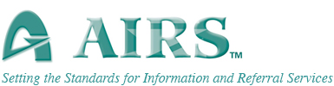](https://www.airs.org/)

The Alliance of Information and Referral Systems is the professional membership association for community Information and Referral (I&R). AIRS is the driving force behind the delivery of quality I&R services and the sole source for standards, program accreditation and practitioner certification for the I&R sector.

Our diverse membership consists of individuals, agencies, community organizations, governmental departments and others, located primarily in the United States and Canada, who help connect people to the services they require. Thousands of I&R practitioners in our member organizations answer approximately 28 million inquiries a year about community, social and health services.

For more information about AIRS visit their website at [www.airs.org](http://www.airs.org).

**Questions about the Conference?**

If you have questions about registration, conference sessions or general questions, contact:

**Mary Updike 715-537-6225 ext. 6838 or email at:**

**mary.updike@co.barron.wi.us**

**Email** [**wisconsinairs@gmail.com**](mailto:wisconsinairs@gmail.com) **or contact**

**Any WisconsinAIRS Board Member!**

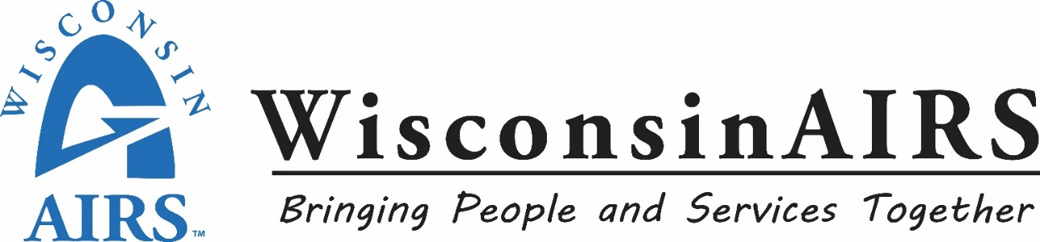

**The WisconsinAIRS Board of Directors**

***Thank You for participating in our***

***2021 Conference!***